 | PharmaTechno  We sale Refurbished vial crimping machine | PharmaTechno Pty Ltd  20 Campbell Street  Punchbowl 2196 - NSW  Australia  Tel : +61 0 415134030  ABN 85783786049  www.pharmatechno.com  info@pharmatechno.com

- 20mm Flip Off Vial Crimper
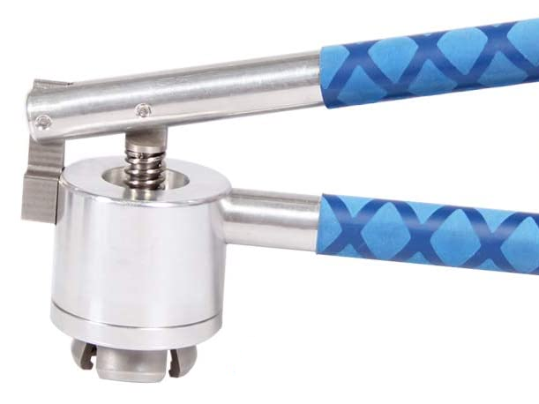

- 20mm Stainless Steel Manual Vial Crimper Hand Sealing Machine

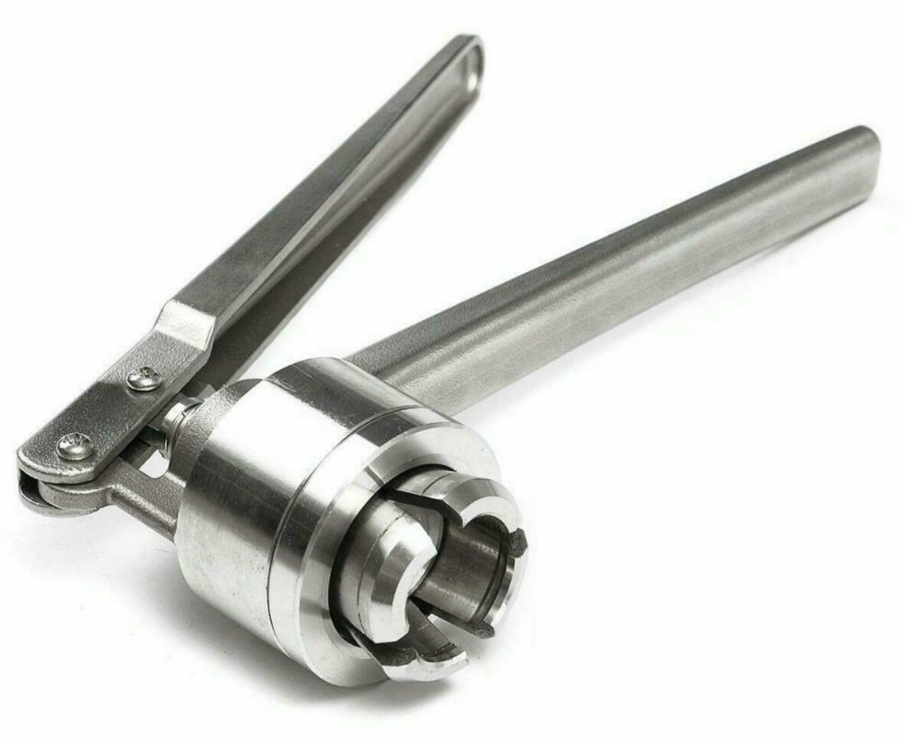

- Semi Automatic Bench TopVial Capping Machine With Removable Head Sizes

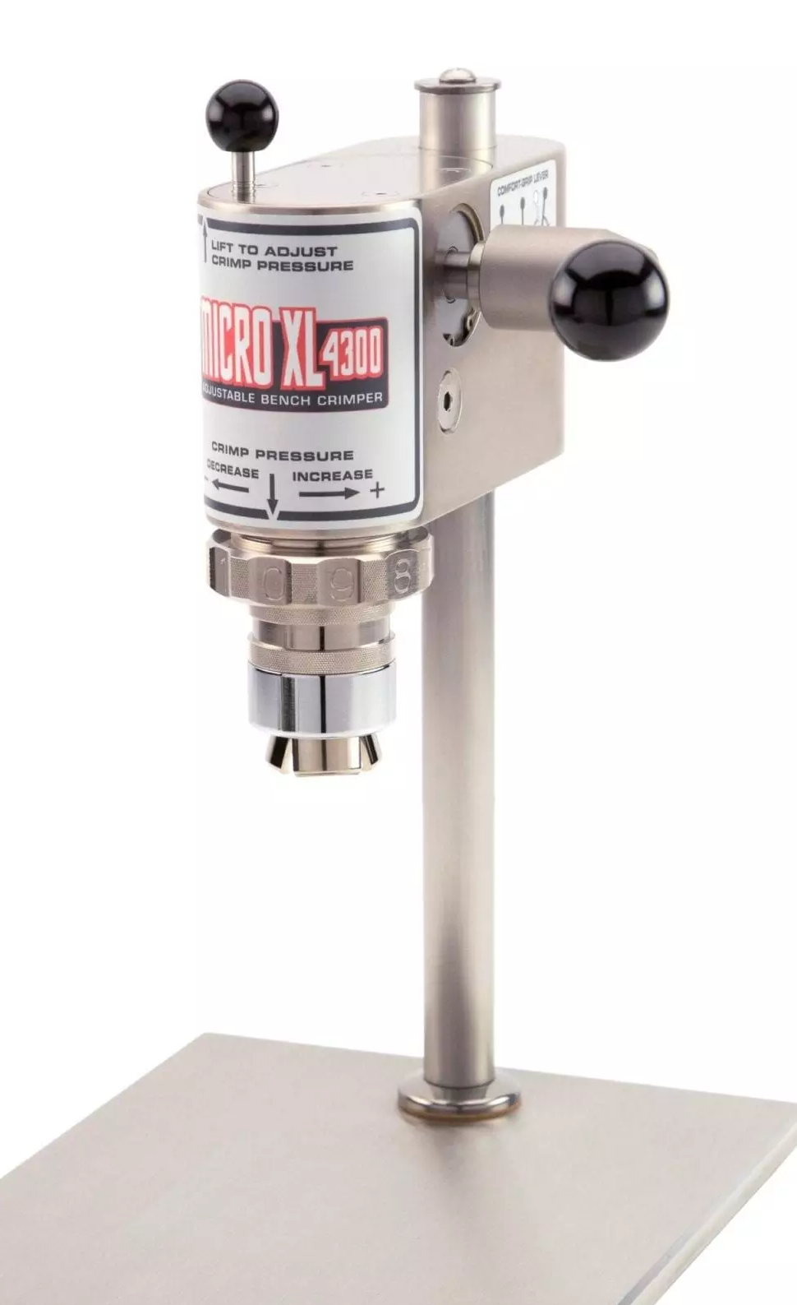

- Manual Vial Crimping Machine With Adjustable Head Sizes


